**Assignment Subjective Questions**

**Q1. Which are the top three variables in your model which contribute most towards the probability of a lead getting converted?**

**Answer:**

Based on the coefficient values from below screeshot, the following are the top three variables that contribute most towards the probability of a lead getting converted :

1. Total Time Spent on Website
2. Lead Add Form (from Lead Origin)
3. Had a Phone Conversation ( from Last Notable Activity)

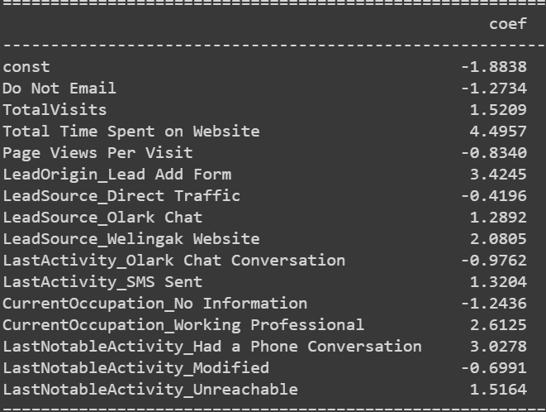

**Q2. What are the top 3 categorical/dummy variables in the model which should be focused the most on in order to increase the probability of lead conversion?**

**Answer:**

Based on the coefficient values from the screenshot in the question above, the following are the top 3 categorical/dummy variables that should be focused the most in order to increase the probability of lead conversion :

1. Lead Add Form (from Lead Origin)
2. Had a Phone Conversation ( from Last Notable Activity)
3. Working Professional ( from What is your current occupation)

**Q3. X Education has a period of 2 months every year during which they hire some interns. The sales team, in particular, has around 10 interns allotted to them. So, during this phase, they wish to make the lead conversion more aggressive. So, they want almost all of the potential leads (i.e., the customers who have been predicted as 1 by the model) to be converted and hence, want to make phone calls to as much of such people as possible. Suggest a good strategy they should employ at this stage.**

**Answer:**

Here are some specific Leads that X Education should focus on to increase their lead conversion rate:

* Leads who spend more time on the website are more likely to convert. This is likely because they are more interested in the company's products or services and are taking the time to learn more about them.
* Leads who come from the lead add form are more likely to convert. This is likely because these leads have already expressed interest in the company's products or services by filling out the form.
* Leads who have had a phone conversation with a sales representative are more likely to convert. This is likely because these leads have had the opportunity to learn more about the company and its products or services from a sales representative who can answer their questions and address their concerns.
* **Use the lead score to prioritize leads,** leads with a score more than 85 are considered to be Hot Leads.

**Here are some Potential Leads for X Education company to call,**

Potential_leads = y_pred_final.loc[y_pred_final["Lead_Score"]>=85]

Potential_leads_IDs = Potential_leads["Prospect ID"].values.reshape(-1)

print(Potential_leads_IDs)

**Q4. Similarly, at times, the company reaches its target for a quarter before the deadline. During this time, the company wants the sales team to focus on some new work as well. So, during this time, the company’s aim is to not make phone calls unless it’s extremely necessary, i.e., they want to minimize the rate of useless phone calls. Suggest a strategy they should employ at this stage.**

**Answer:**

Here are some specific Leads that X Education should not focus on to increase their lead conversion rate:

* Leads who have marked themselves as "Do Not Call" are less likely to convert. These leads are not interested in receiving sales calls and are more likely to hang up on sales representatives.
* Leads who were approached upfront are not extremely necessary to call to convert and as they are already interested in the company's products or services.
* Leads who are housewives are less likely to convert. Housewives may have less time to research and purchase products or services than other leads.
* Leads who were already converted to leads are more likely to convert in the future. These leads have already expressed interest in the company's products or services. Such leads can be converted through other methods like SMS or automated mails
* **Use the lead score to prioritize leads,** leads with a score less than 25 are considered to be Useless Leads.

**Here are some Useless Leads for X Education company to call,**

Useless_leads = y_pred_final.loc[y_pred_final["Lead_Score"]<=25]

Useless_leads_IDs = Useless_leads["Prospect ID"].values.reshape(-1)

print(Useless_leads_IDs)